https://www.arduino.cc/
select Arduino 1.8.19
To install the ESP32 board in your Arduino IDE, follow these next instructions:
- In your Arduino IDE, go to File> Preferences
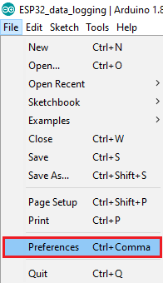
- Enter the following into the “Additional Board Manager URLs” field:
https://raw.githubusercontent.com/espressif/arduino-esp32/gh-pages/package_esp32_index.json
- Then, click the “OK” button:
- 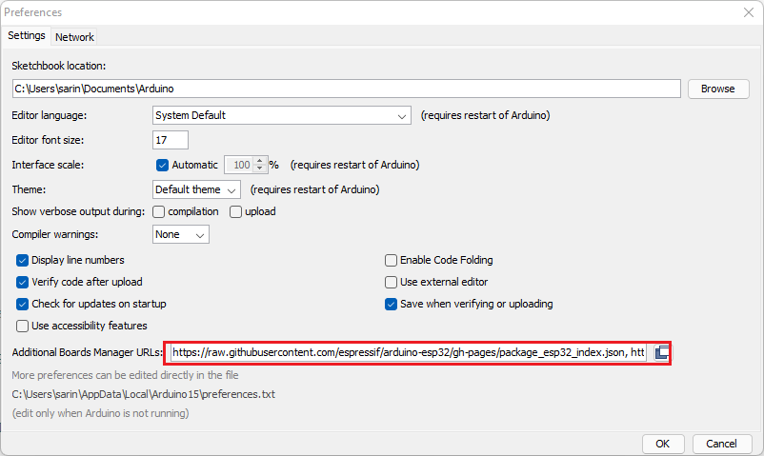

• Open the Boards Manager. Go to Tools > Board > Boards Manager…
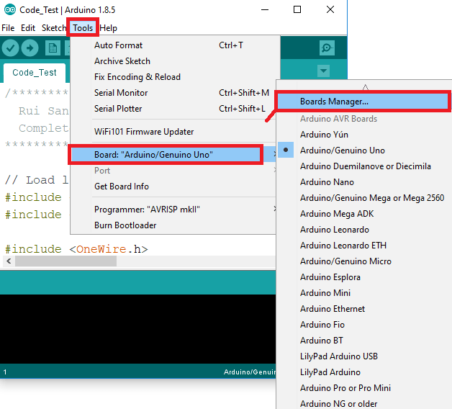
• Search for ESP32 and press install button for the “ESP32 by Espressif Systems“:
• 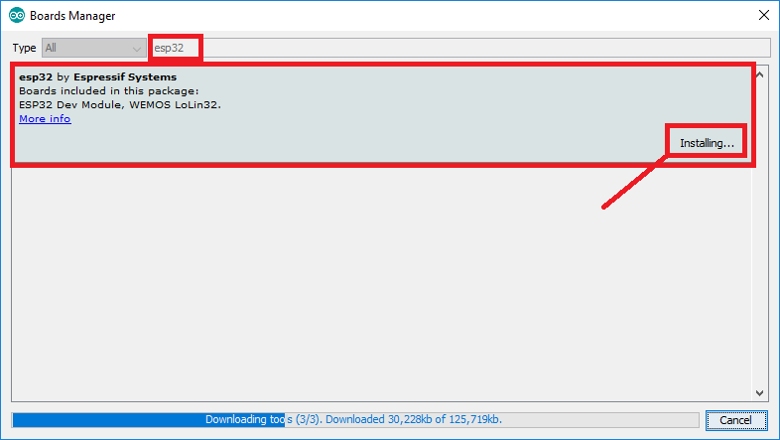
• That’s it. It should be installed after a few seconds.
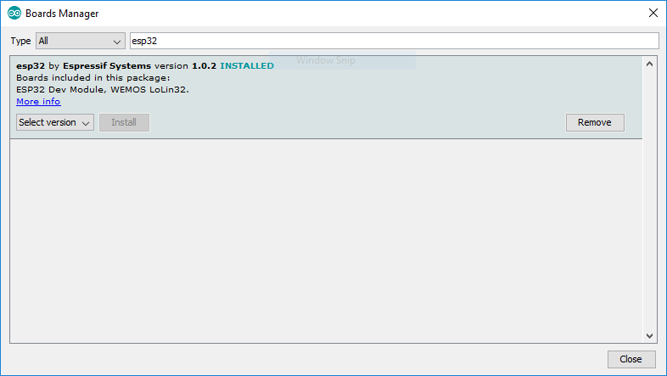
Selectionner version 2.0.17
Installer driver I²C SSD1306
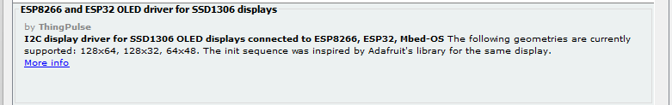
Par la suite nous allons utiliser la librairie PubSubClient.
1. Cliquez sur "Croquis" puis "inclure une bibliothèque" puis "Gérez les bibliothèques"
2. Dans la barre de recherche tapez "PubSubClient".
3. Retrouvez la librairie "PubSubClient" de "Nick O'Leary" et cliquez sur "install"
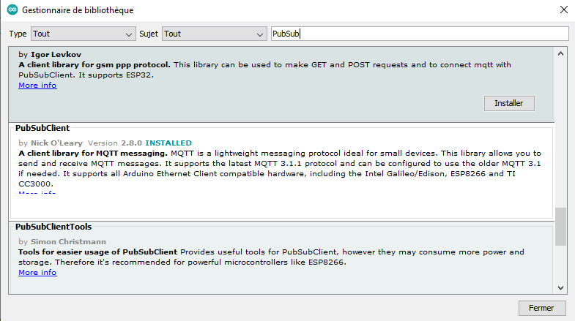
Async tcp esp32a
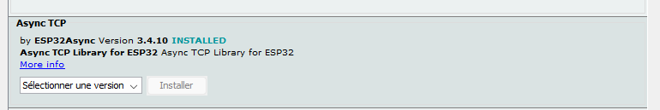
Elegant ota
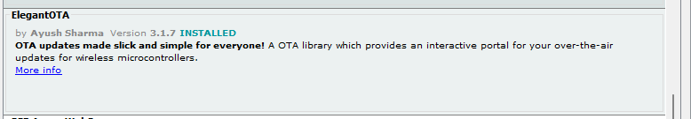
ESP Async Webserver
